SQL CLASS EXERSICES
NAME: AJITH E JOEMON
PROGRAMME: MSC CS
ROLL NO: 3

1.1. Retrieval of Data

1. SELECT Name
FROM Cust_Master;
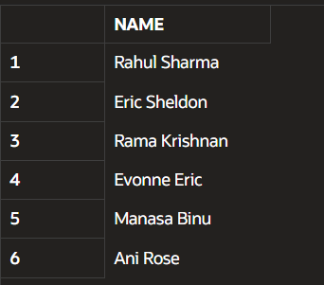

2. SELECT *
FROM Cust_Master;
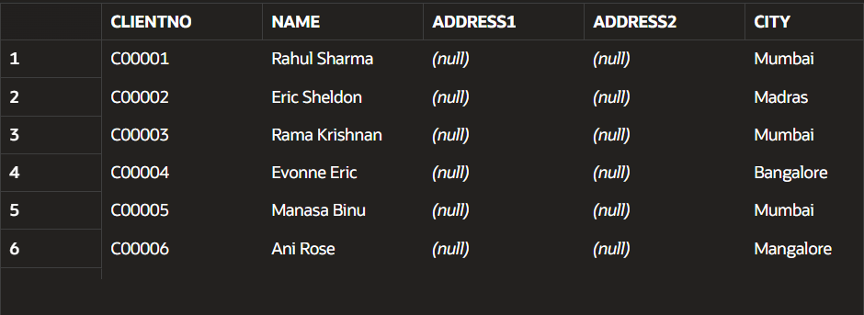
3. SELECT Name, City, State FROM Cust_Master;
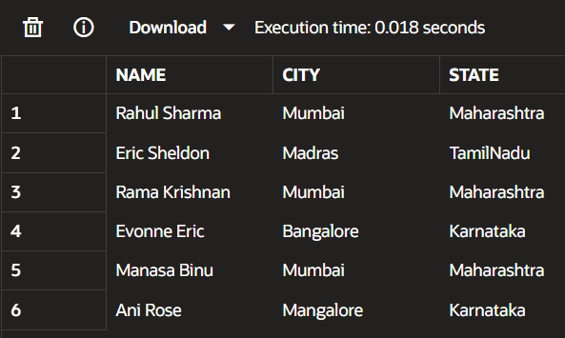

4. SELECT *
FROM Prod_Master
ORDER BY Description DESC;
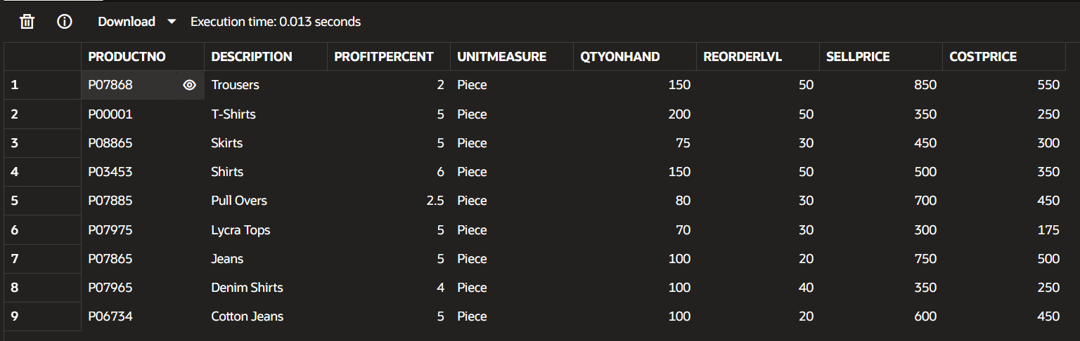

5. SELECT *
FROM Cust_Master
WHERE City = 'Mumbai';
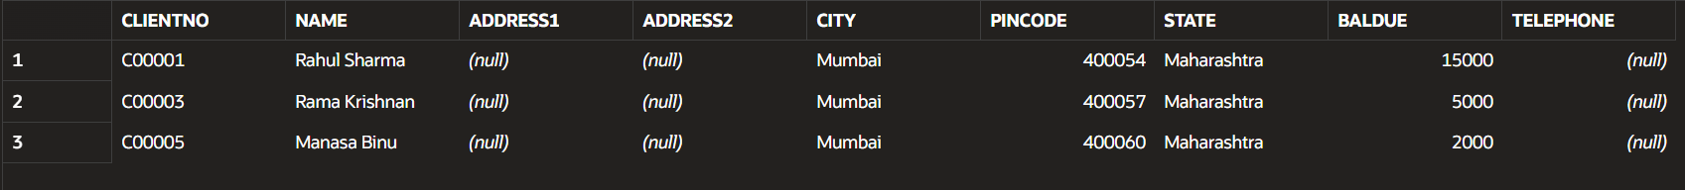

6. SELECT Name
FROM Cust_Master
WHERE Name LIKE '_a%';
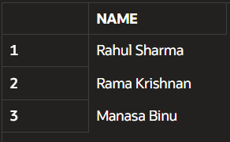

7. SELECT *
FROM Cust_Master
WHERE City LIKE 'M%';

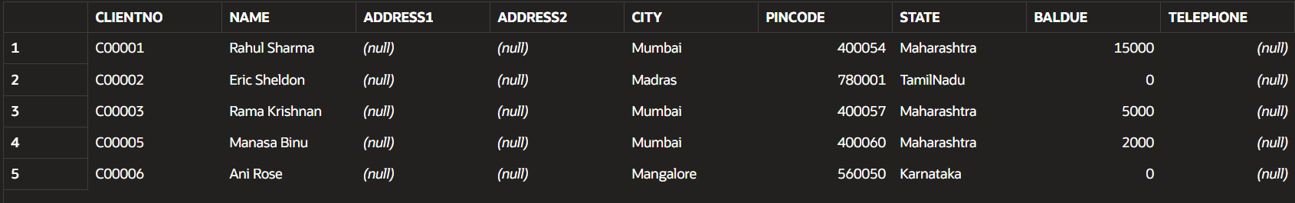

8. SELECT * FROM Cust_Master WHERE City IN ('Bangalore', 'Mangalore');
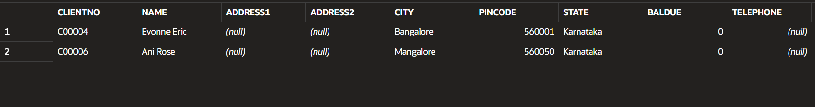

9. SELECT * FROM Prod_Master WHERE Description LIKE '%Shirts%';
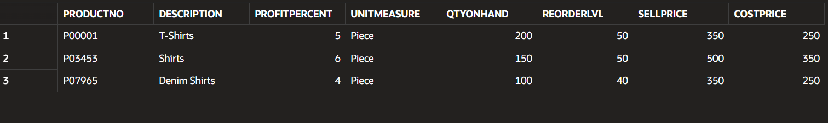

10. SELECT * FROM Cust_Master WHERE BalDue > 10000;

11. SELECT * FROM Prod_Master WHERE SellPrice > 500 AND SellPrice <= 750;
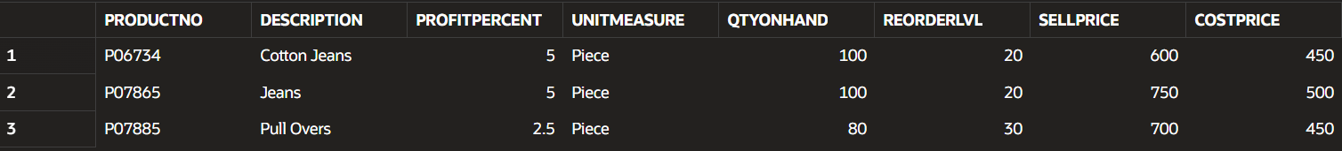

12.SELECT ProductNo, Description, SellPrice, SellPrice * 2 AS New_Price FROM Prod_Master WHERE SellPrice > 500;
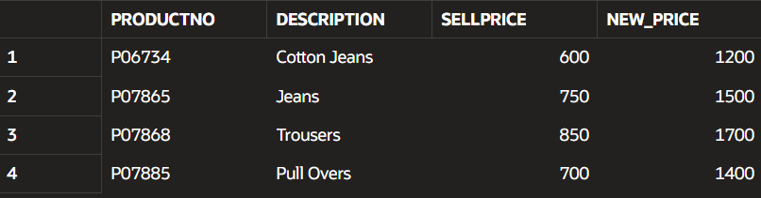

13. SELECT * FROM Prod_Master WHERE QtyOnHand < ReorderLvl;
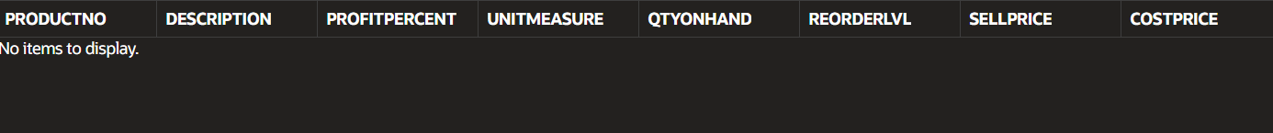

14. SELECT * FROM Sales_Order WHERE ClientNo IN ('C00001', 'C00002');
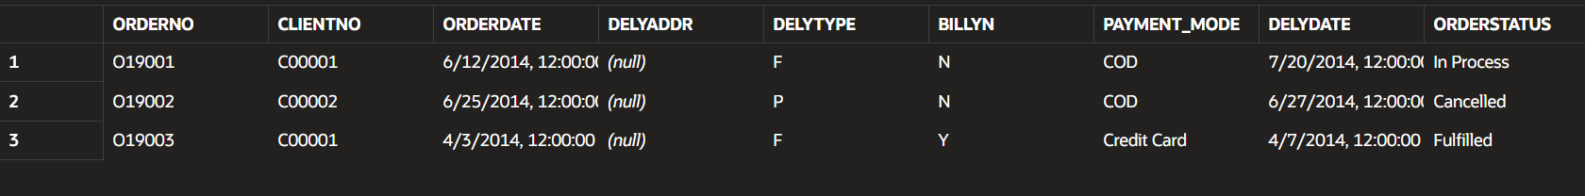

15. SELECT Name, City, State FROM Cust_Master WHERE State <> 'Maharashtra';
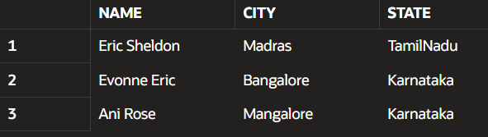

1.2. Data Manipulations using Date Functions
1. SELECT OrderNo, TO_CHAR(OrderDate, 'DAY') AS Day FROM Sales_Order;
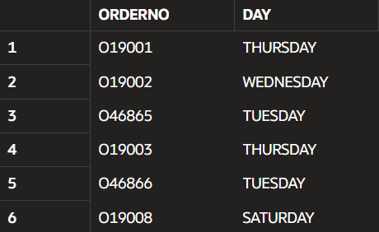

2. SELECT TO_CHAR(DelyDate, 'MONTH') AS Month, DelyDate FROM Sales_Order;
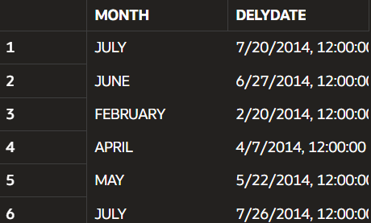

3. SELECT TO_CHAR(OrderDate, 'DD-MONTH-YY') AS Order_Date
FROM Sales_Order;
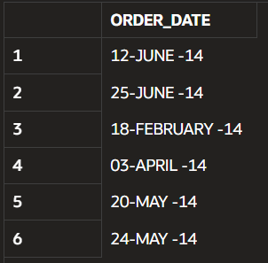

4. SELECT SYSDATE + 15 AS New_Date FROM DUAL;

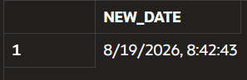
5. SELECT * FROM Sales_Order WHERE TO_CHAR(OrderDate, 'MONTH') LIKE 'JUNE%';

6.DATE FUNCTIONS
6.1.SELECT TO_DATE('12-JUN-2014', 'DD-MON-YYYY') FROM DUAL;
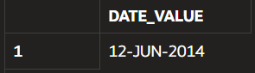
6.2. SELECT ADD_MONTHS(SYSDATE, 3) FROM DUAL;
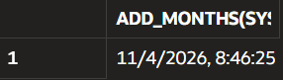

6.3. SELECT MONTHS_BETWEEN(SYSDATE, TO_DATE('01-JAN-2024', 'DD-MON-YYYY')) FROM DUAL;
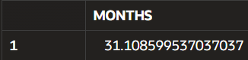
6.4.SELECT NEXT_DAY(SYSDATE, 'MONDAY')
FROM DUAL;
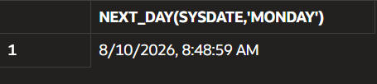

6.5. SELECT ROUND(SYSDATE, 'MONTH')
FROM DUAL;
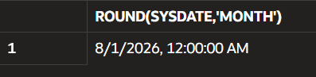

7. Illustrate special date formats using TO_CHAR

7.1.SELECT TO_CHAR(SYSDATE, 'DDTH MONTH YYYY') FROM DUAL;
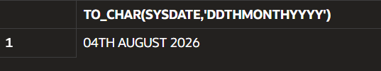
7.2. SELECT TO_CHAR(SYSDATE, 'DDSP') FROM DUAL;
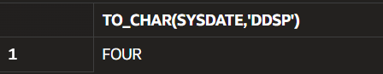
7.3. SELECT TO_CHAR(SYSDATE, 'DDSPTH') FROM DUAL;
